Overview
In order to get a little bit of practice with Bootstrap, we have two fairly straightforward labs that will allow you to use the Grid Layout system and Forms in Bootstrap.

The image assets and requirements needed for the labs can be found in the cohort shared repository under:

labs → webui → twitter_bootstrap → lab_01_layout

labs → webui → twitter_bootstrap → lab_02_forms

Lab 1 - Layout
The purpose of Lab 1 is to give you practice with Bootstrap’s grid layout system. Your final page should look like this:

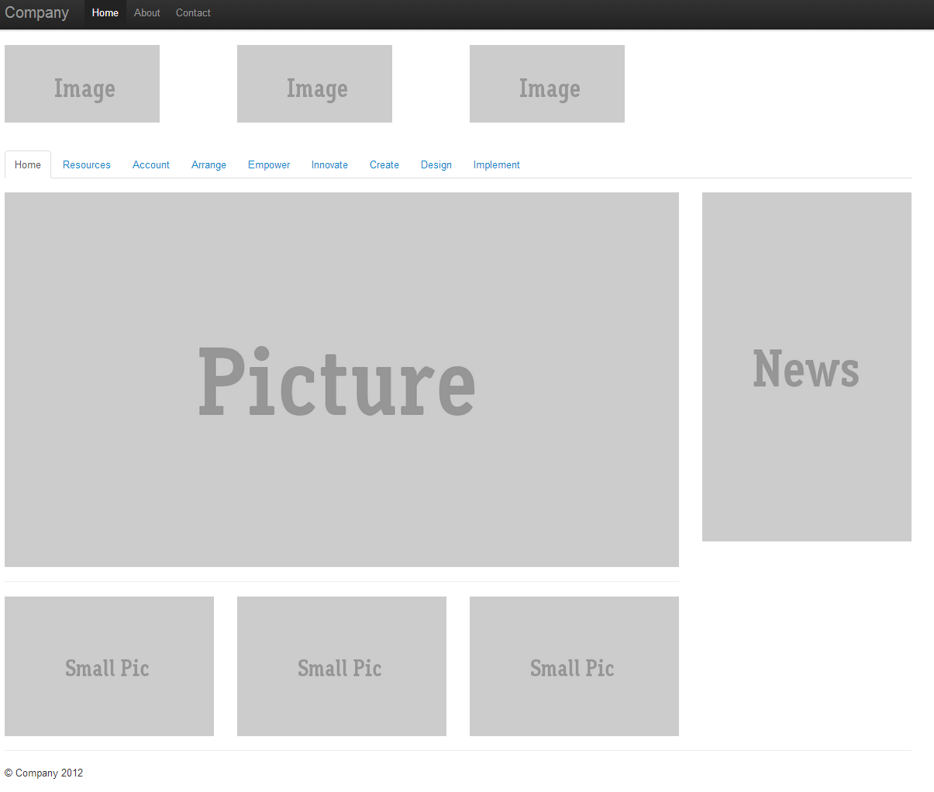
The images needed to complete this lab are in the assets folder. You will need to included the Bootstrap CSS files and JavaScript files in order to complete this lab. You will also need a Nav Bar and Tabs - the rest should be accomplished using the Bootstrap Grid Layout system.

Lab 2 - Forms
The purpose of this lab is to give you practice rendering forms with the Bootstrap framework. You will create two forms on the same page that are floating next to each other. Your final page will look like this:

